CSA6102 – DIGITAL FORENSICS AND CYBERCRIME INVESTIGATION

Y.HARSHA VARDHAN(192465030)

EXP 1

1. Write a Python program to demonstrate Locard's Exchange Principle using file timestamps (metadata trace demo).

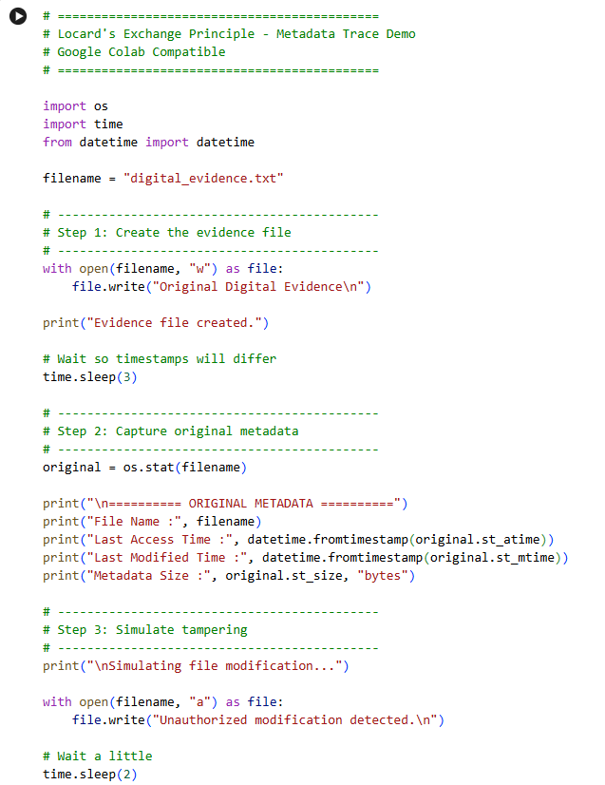
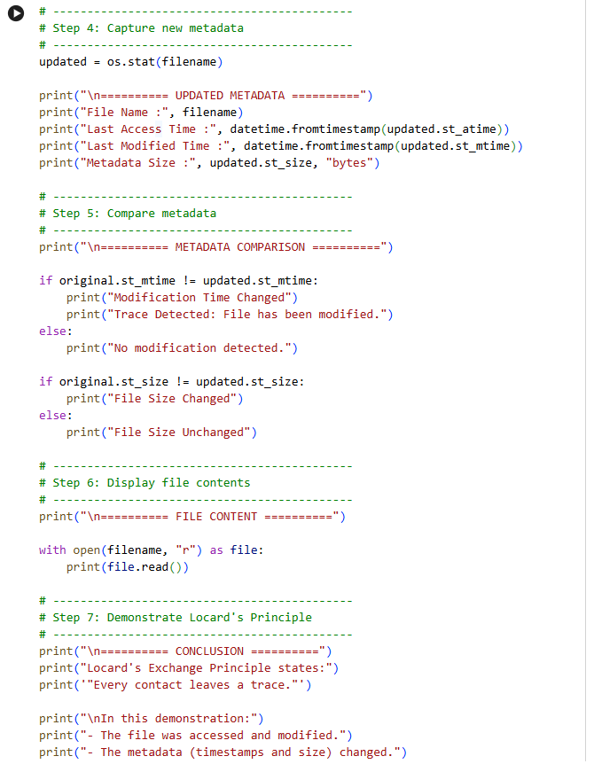

OUTPUT :

